Databases Assignment – Zahara Vazir – 18417696

For my report I will go through the different tables I have created and the assumptions I have made for this assignment. I created 7 entities in total.

I had a hospital details table in which I populated it with the information about the hospital including the hospital identifier, which I made the primary key, name, address and telephone number. The id for the hospital will be a foreign key in other entities.

My next table included candidate details. For this table my attributes were candidate_identifier, which again is a primary key for this table, first name, surname, address and telephone number.

My third entity was a position table. The two attributes I had for this table were the position_identifier, the primary key, and the type of position.

My fourth entity was interview_details. Here I had an interview identifier which was the primary key. I had three foreign keys in this table, hospital_identifier, candidate_identifier and position_identifier. This is creating a link between the tables, hospital_details, candidate_details and and position_details. Two of my other columns were date and time. This is all the data about the interviews that took place for the candidate and it displayed whether they got the job or not in the offers attribute.

My fifth entity is skills. Here I had two attributes which were skill_identifier and skill_name. I made skill_identifier a primary key. the primary key I have made in this entity, I made it a foreign key in my required_skills and candidate_skill_set entity.

Number six was required_skill. In this table I have two attributes, postion_identifier and skill_identifier. These are both foreign keys in this table. There is a many to many relationship here, as many positions can have many different skills and a skill can corelate to many different positions.

For my last entity, I called it candidate_skill_set. The attributes I had for this entity were candidate_identifier and skills identifier. These both are foreign keys and again this is a many to many relationship, as many candidates can possess many different skills and again a skill can relate to more than one candidate.

To populate this table, I used storage procedures. This involved creating parameters in which values can be inputted by the user. With this given information, the data that we are trying to find from the entities will be extracted and shown to us.

**Assumptions for this assignment :**

* The assumptions I made for this assignment included how a candidate can’t be employed if they already are employed somewhere else.
* Another assumption is that how every candidate who is being interviewed has a degree for the position they are applying for.
* A candidate can apply for one position only but at different hospitals.
* If a candidate has interviewed for a position at different hospitals, they will only get an offer from one of those hospitals.

ER Diagram :

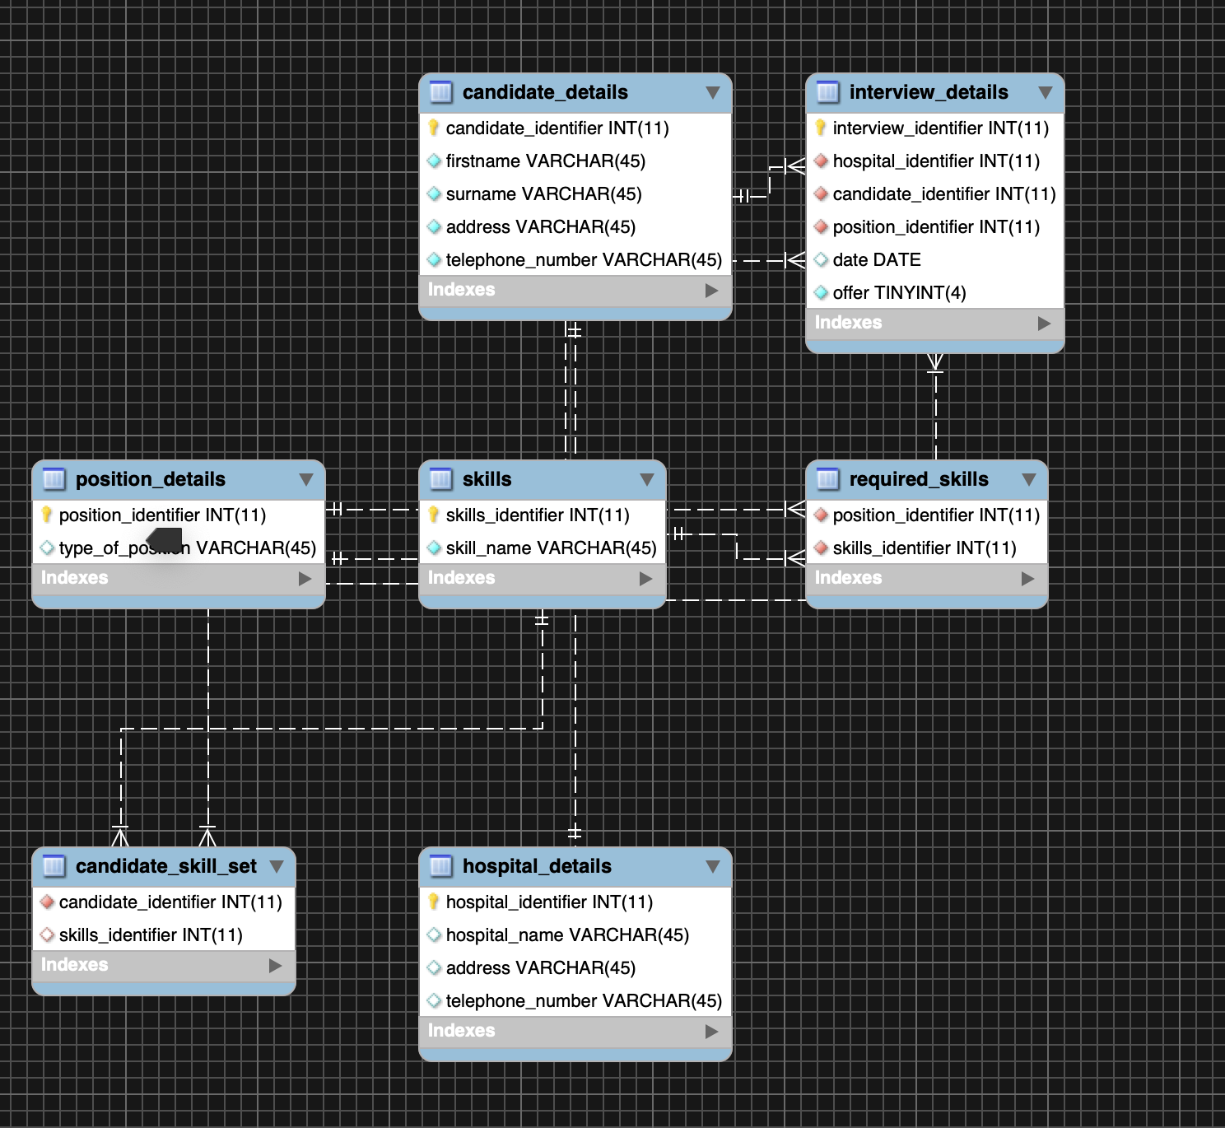

Mac operating System